Test Case: tc001_SPX_Dev5_Crear_Requisicion_Spot_Tipo_Cobro_CC
Step 1 - Enter username and password and click to button Enter : Credentials Entered
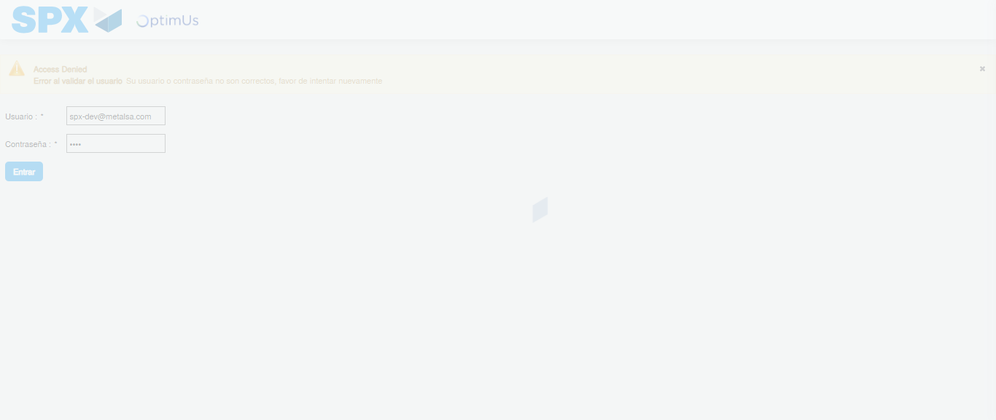Image file-name: QC_Testing-tc001_SPX_Dev5_Crear_Requisicion_Spot_Tipo_Cobro_CC-1783978125565

Step 2 - Select to UEN and Access to Spot Buy Requisitions : UEN Correctly selected and Correct access
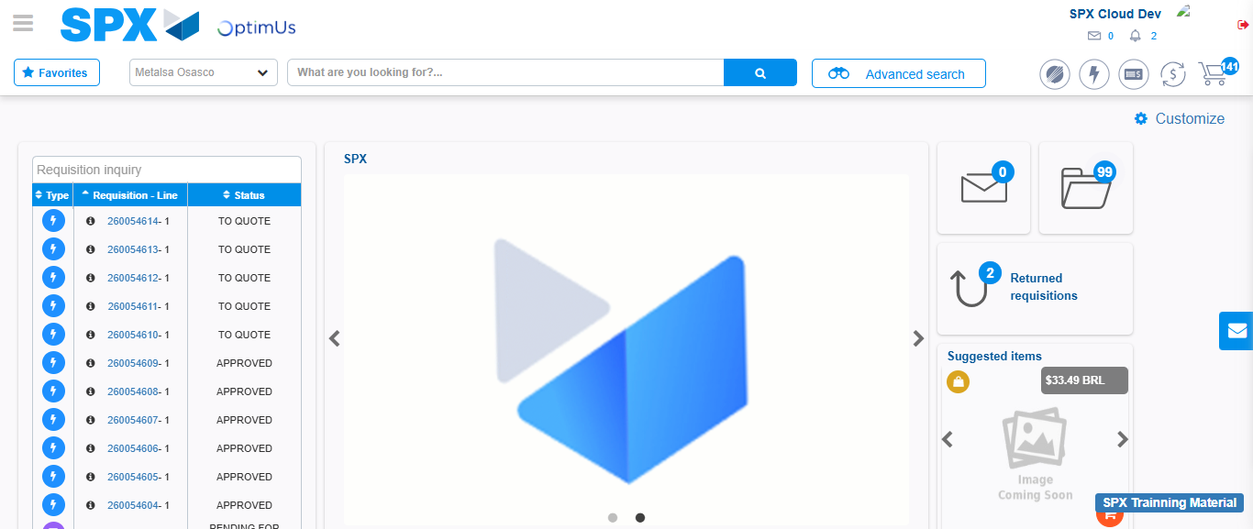Image file-name: QC_Testing-tc001_SPX_Dev5_Crear_Requisicion_Spot_Tipo_Cobro_CC-1783978198118

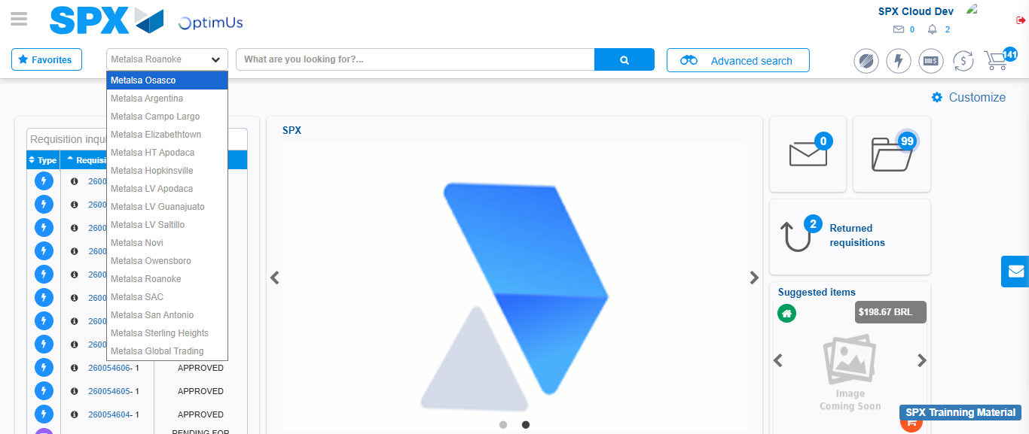Image file-name: QC_Testing-tc001_SPX_Dev5_Crear_Requisicion_Spot_Tipo_Cobro_CC-1783978200766

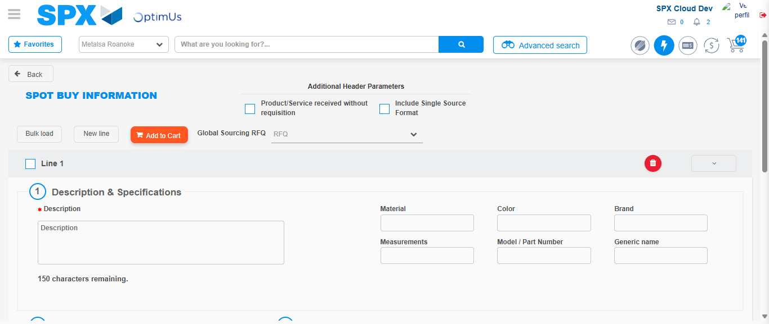Image file-name: QC_Testing-tc001_SPX_Dev5_Crear_Requisicion_Spot_Tipo_Cobro_CC-1783978208936

Step 3 - Data Capture Spot Buy Requisition : Data captured correctly
Image file-name: QC_Testing-tc001_SPX_Dev5_Crear_Requisicion_Spot_Tipo_Cobro_CC-1783978209166

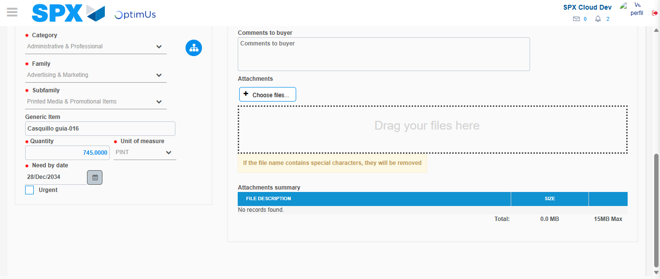Image file-name: QC_Testing-tc001_SPX_Dev5_Crear_Requisicion_Spot_Tipo_Cobro_CC-1783978220156

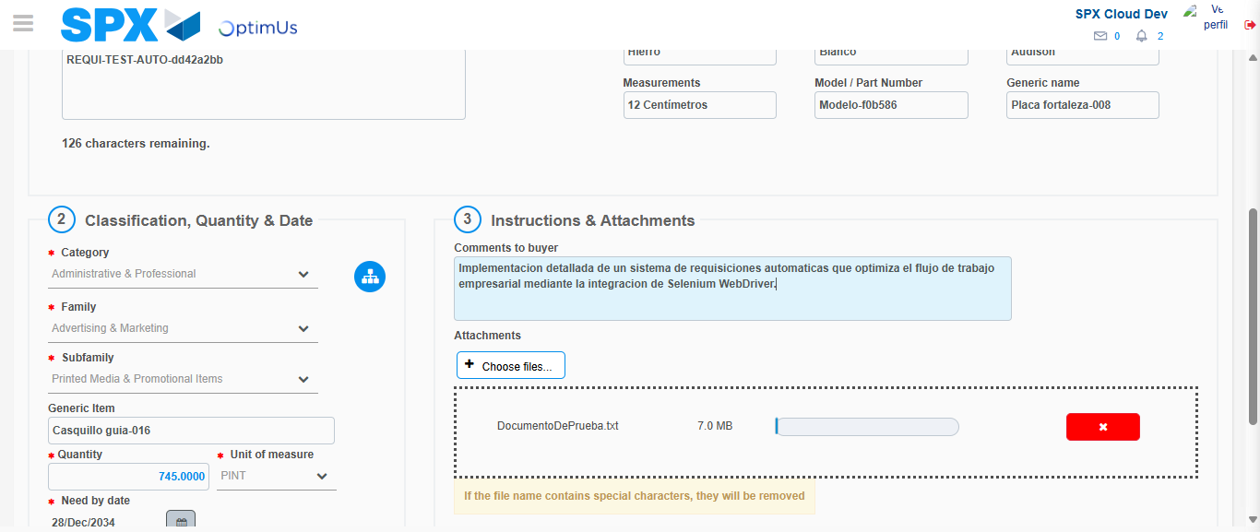Image file-name: QC_Testing-tc001_SPX_Dev5_Crear_Requisicion_Spot_Tipo_Cobro_CC-1783978220889

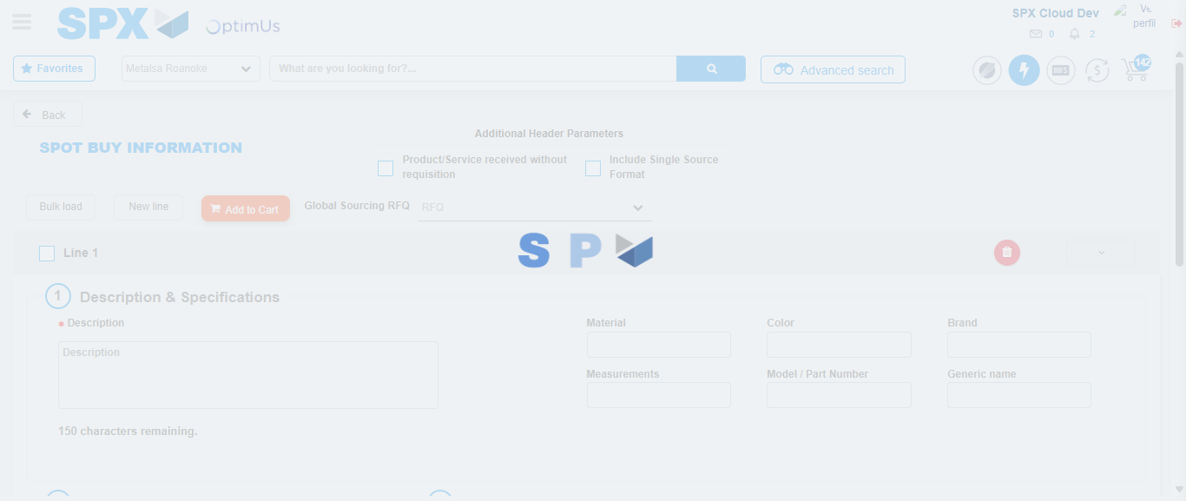Image file-name: QC_Testing-tc001_SPX_Dev5_Crear_Requisicion_Spot_Tipo_Cobro_CC-1783978224962

Step 7 - Return to Main Page SPX : Return to Main Page SPX
Image file-name: QC_Testing-tc001_SPX_Dev5_Crear_Requisicion_Spot_Tipo_Cobro_CC-1783978198118

Image file-name: QC_Testing-tc001_SPX_Dev5_Crear_Requisicion_Spot_Tipo_Cobro_CC-1783978200766

Image file-name: QC_Testing-tc001_SPX_Dev5_Crear_Requisicion_Spot_Tipo_Cobro_CC-1783978208936

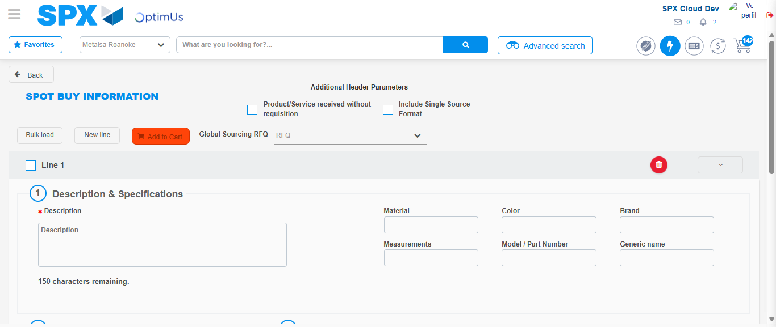Image file-name: QC_Testing-tc001_SPX_Dev5_Crear_Requisicion_Spot_Tipo_Cobro_CC-1783978227177

Image file-name: QC_Testing-tc001_SPX_Dev5_Crear_Requisicion_Spot_Tipo_Cobro_CC-1783978227344

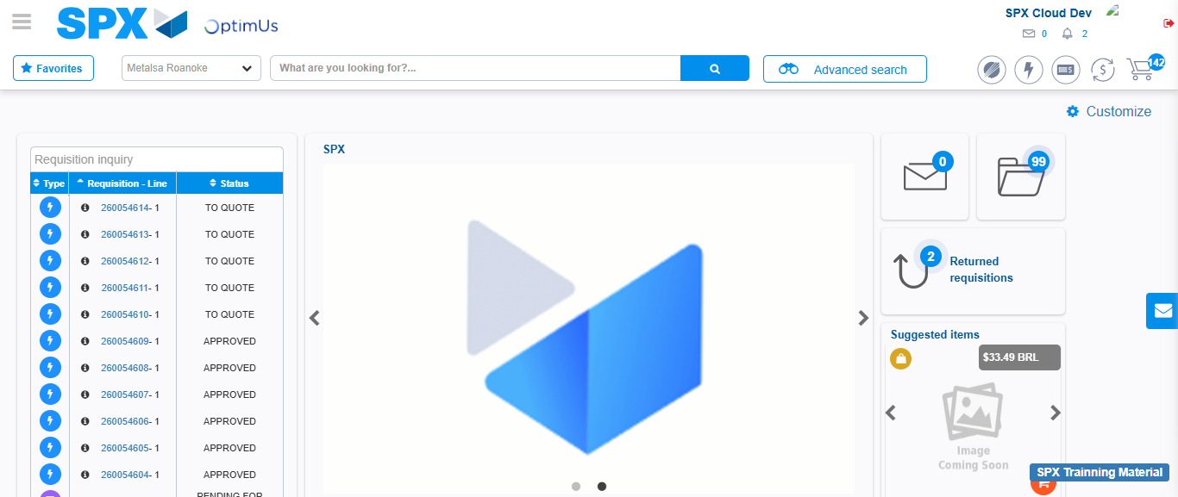Image file-name: QC_Testing-tc001_SPX_Dev5_Crear_Requisicion_Spot_Tipo_Cobro_CC-1783978248357

Step 8 - Log Out : Log Out SPX
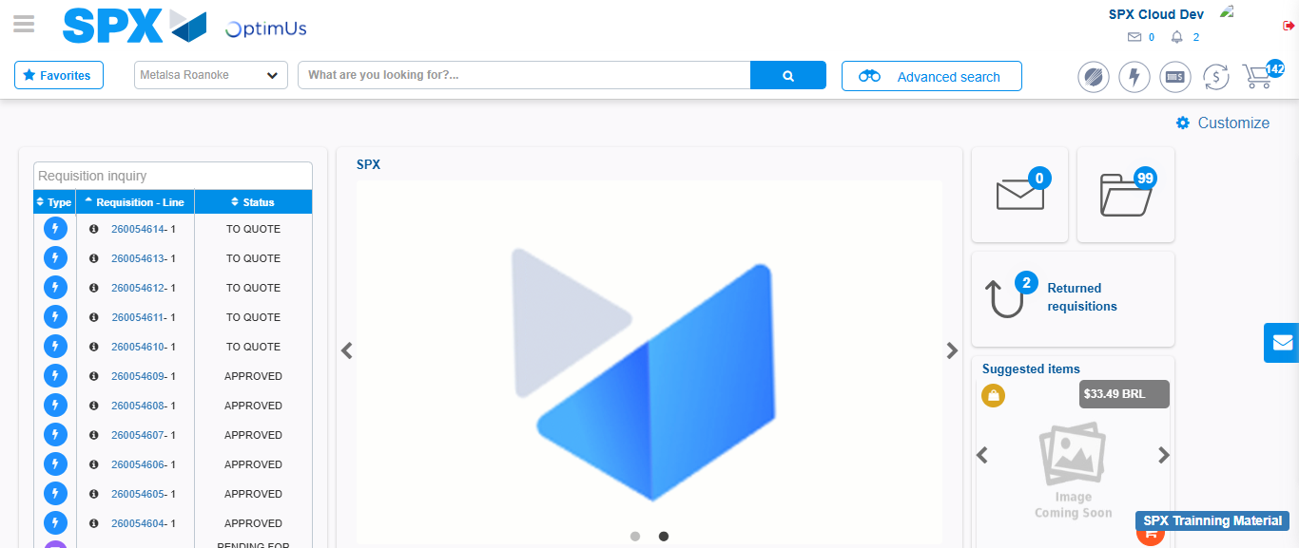Image file-name: QC_Testing-tc001_SPX_Dev5_Crear_Requisicion_Spot_Tipo_Cobro_CC-1783978248662

